Exercício form005.html

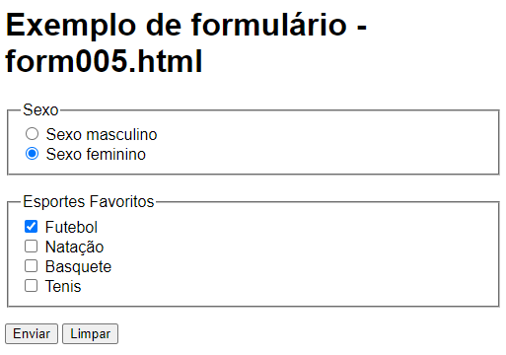

<**body**>

<h1>**Exemplo de formulário - form005.html**</h1>

<**form** action="**cadastro.php**" method="**get**">

<**fieldset**>

<**legend**>**Sexo**</**legend**>

<**input** **type**="**radio**" name="**sexo**" id="**i_sexo-mas**">   
<**label** **for**="**i_sexo-mas**"> **Sexo masculino** </**label**><br>

<**input** **type**="**radio**" name="**sexo**" id="**i_sexo-fem**" checked >  
<**label** **for**="**i_sexo-fem**"> **Sexo feminino** </**label**> <br>

</**fieldset**>

<br>

<**fieldset**>

<**legend**>Esportes Favoritos</**legend**>

<**input** **type**="**checkbox**" name="**esp_fute**" id="**i_esp_fute**" checked>  
<**label** **for**="**i_esp_fute**">**Futebol**</**label**> <br>

<**input** **type**="**checkbox**" name="**esp_nata**" id="**i_esp_nata**" >   
<**label** **for**="**i_esp_nata**">**Natação**</**label**> <br>

<**input** **type**="**checkbox**" name="esp_basq" id="**i_esp_basq**" >   
<**label** **for**="**i_esp_basq**">**Basquete**</**label**> <br>

<**input** **type**="**checkbox**" name="esp_tenis" id="**i_esp_tenis**" >   
<**label** **for**="**i_esp_tenis**">**Tenis**</**label**>

</**fieldset**>

<p>

<**input** type="**submit**" value="**Enviar**">

<**input** type="**reset**" value="**Limpar**">

</p>

</**form**>

</**body**>